**The Human Development Index**

**1. INTRODUCTION**

**1.1OVERVIEW**

The Human Development Index (HDI) is a statistical composite index of life expectancy, education, and per capita income indicators, which are used to rank countries into four tiers (very high, high, medium & low) of human development. A country scores a higher HDI when the lifespan is higher, the education level is higher, and the gross national income GNI (PPP) per capita is higher. The HDI was created to emphasize that people and their capabilities should be the ultimate criteria for assessing the development of a country, not economic growth alone. The HDI can also be used to question national policy choices, asking how two countries with the same level of GNI per capita can end up with different human development outcomes. In this project we will be building a machine learning model to predict the Human Development Index of a country by taking a few important aspects as inputs. Our model will at last predict the HDI score of a country and will also tell under which category it falls into (very high, high, medium or low).

* 1. **PURPOSE**

It was created to re-emphasize that people and their capabilities should be the ultimate criteria for assessing the development of a country, not economic growth. The HDI is used to capture the attention of policy-makers, the media and nongovernmental organizations, and to change the focus from the usual economic statistics to human outcomes.

The HDI is also used to question national policy choices and to determine how two countries with the same level of income per person can have widely different human development outcomes. For example, two countries may have similar incomes per person, but have drastically differing life expectancy and literacy levels, such that one of the countries has a much higher HDI than the other. These contrasts stimulate debate on government policies concerning health and education to determine why what can be achieved in one country is beyond the reach of the other.

The HDI is also used to highlight differences within countries, between provinces or states, and across genders, ethnicities and other socioeconomic groupings. Highlighting internal disparities along these lines has raised the national debate in many countries.

**2.LITERATURE SURVEY**

* 1. **EXISTING PROBLEM**

In recent years, deep learning has been used in various applications including the classification of ship targets in inland waterways for enhancing intelligent transport systems. Various researchers introduced different classification algorithms, but they still face the problems of low accuracy and misclassification of other target objects. Hence, there is still a need to do more research on solving the above problems to prevent collisions in inland waterways.

* 1. **PROPOSED SYSTEM**

In order to solve the problems for the accuracy of the classification system, we proposed a new classification model. First, based on the pretrained models, the models were fine-tuned with the public dataset we used. Based on their performance, the best model was selected in order to further adjust the performance for high accuracy in classifying ships in inland river waterways. After selecting the best model, the model was adjusted, and classification was conducted based on the modification of the network.

**3. THEORETICAL ANALYSIS**

**3.1 BLOCK DIAGRAM**

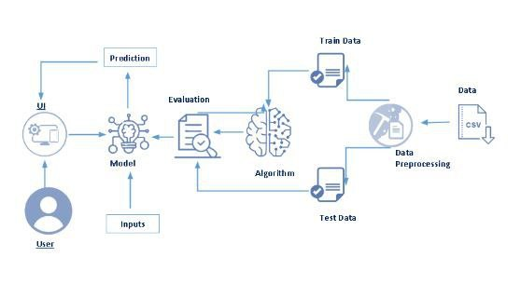

**3.2 HARDWARE AND SOFTWARE DESIGNING**

**Python**

Python is an interpreted, object-oriented, high-level programming language with dynamic semantics. It was created by Guido van Rossum , and first released on February 20, 1991. Its high-level built in data structures, combined with dynamic typing and dynamic binding , make it very attractive for Rapid Application Development, as well as for use as a scripting or glue language to connect existing components together. Python's simple, easy to learn syntax emphasizes readability and therefore reduces the cost of program maintenance. Python supports modules and packages, which encourages program modularity and code reuse. The Python interpreter and the extensive standard library are available in source or binary form without charge for all major platforms, and can be freely distributed.

**Anaconda Navigator**

Anaconda Navigator is a free and open-source distribution of the Python and R programming languages for data science and machine learning related applications. It can be installed on Windows, Linux, and macOS.Conda is an open-source, crossplatform, package management system. Anaconda comes with so very nice tools like JupyterLab, Jupyter Notebook, QtConsole, Spyder, Glueviz, Orange, Rstudio, Visual Studio Code. For this project, we will be using Jupyter notebook and Spyder.

**Jupyter Notebook**

The Jupyter Notebook is an open source web application that you can use to create and share documents that contain live code, equations, visualizations, and text. Jupyter Notebook is maintained by the people at Project Jupyter. Jupyter Notebooks are a spin-off project from the IPython project, which used to have an IPython Notebook project itself. The name, Jupyter, comes from the core supported programming languages that it supports: Julia, Python, and R. Jupyter ships with the IPython kernel, which allows you to write your programs in Python, but there are currently over 100 other kernels that you can also use.

**Spyder**

Spyder, the Scientific Python Development Environment, is a free integrated development environment (IDE) that is included with Anaconda. It includes editing, interactive testing, debugging, and introspection features. Initially created and developed by Pierre Raybaut in 2009, since 2012 Spyder has been maintained and continuously improved by a team of scientific Python developers and the community.Spyder is extensible with first-party and third party plugins includes support for interactive tools for data inspection and embeds Pythonspecific code. Spyder is also pre-installed in Anaconda Navigator, which is included in Anaconda.

**Flask**

Webframework used for building. It is a web application framework written in python which will be running in local browser with a user interface. In this application, whenever the user interacts with UI and selects emoji, it will suggest the best and top movies of that genre to the user.

**Hardware Requirements:**

o Operating system: window 7 and above with 64bit

o Processor Type -Intel Core i3-3220

o RAM: 4Gb and above

o Hard disk: min 100GB

**4. EXPERIMENTAL INVESTIGATION**

The text data need to be organized before proceeding with the project. The original dataset has a single folder. We will be using the HDI.csv file to fetch the text data of training data. The datas need to be unique and all fields need to be filled.The dataset images are to be pre-processed before giving to the model. We will create a function that uses the pre-trained model for predicting custom outputs. Then we have to test and train the model. After the model is build, we will be integrating it to a web application.

**5. FLOWCHART**

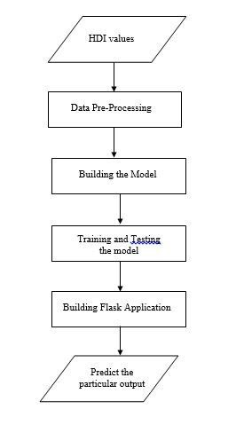

**6.RESULT**



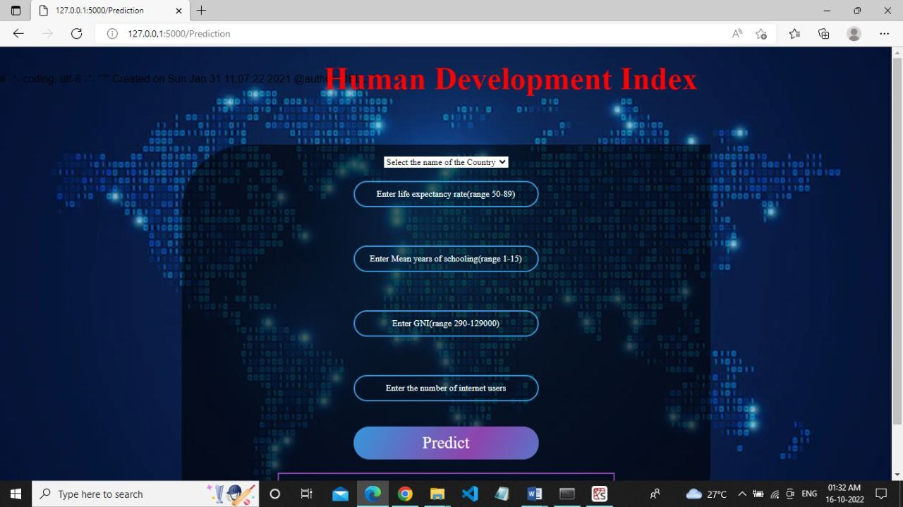

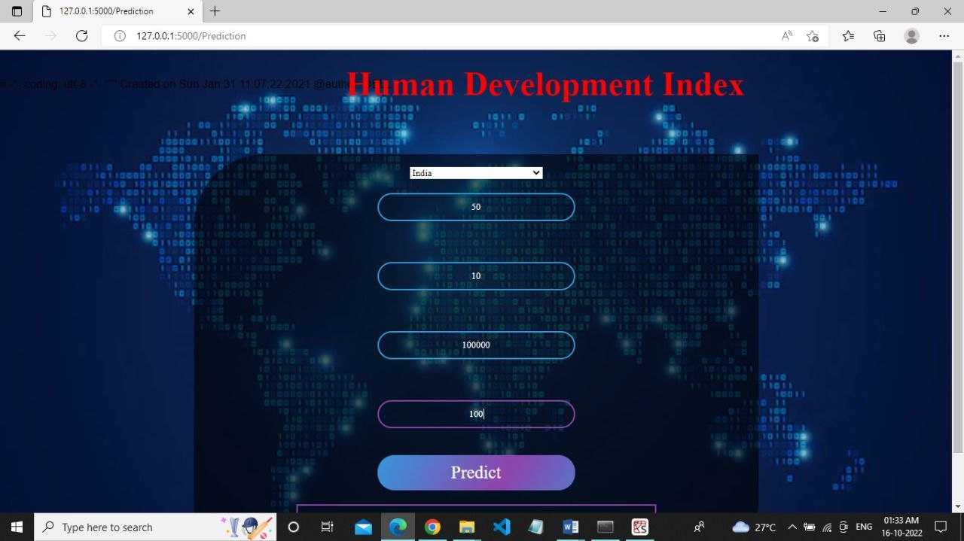

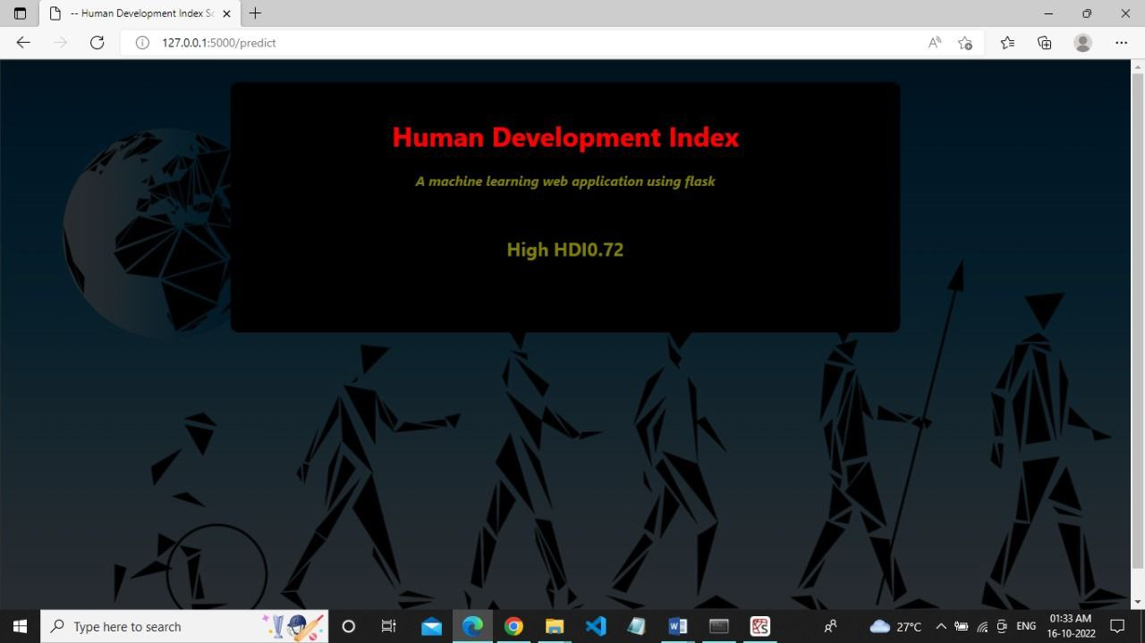

**7.ADVANTAGES**

* Easy to use
* Cost efficient
* Time efficient

**8. CONCLUSION**

This project was about classifying the countries based on their human development index. This project improved the performance of the classification model for classifying people accordingly. The new proposed method achieved high accuracy compared with the other existing algorithms. It was compared with other existing algorithms in classifying different classes of ships in inland waterways, and our proposed method achieved better results compared with the others.

**9. FUTURE SCOPE**

In future works, the proposed method will be improved in order to classify the people in different countries with extra features using more advanced technology.

**10.BIBILOGRAPHY**

<https://hdr.undp.org/data-center/human-development-index#/indicies/HDI>

<https://en.wikipedia.org/wiki/Human_Development_Index>

**APPENDIX**

[**https://github.com/smartinternz02/SI-GuidedProject-319314-1664617907**](https://github.com/smartinternz02/SI-GuidedProject-319314-1664617907)